CCHS Mathematics II
Probability
Module 9 - Assessment Study Guide

Define the following Mathematical Terms

Probability function | Probability of events intersection | Probability of events union | Conditional probability function
Percentage | Hearts | Clubs | Spades
Diamonds | Venn Diagram | Frequency Table | 2-Way Table

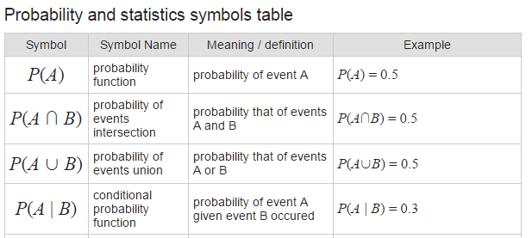
http://www.rapidtables.com/math/symbols/Statistical_Symbols.htm

Understand the following Tasks
- Find the probability of a function.
- Find the probability of events intersection.
- Find the probability of events union.
- Find the conditional probability function.
- Use probability notation.
- Use a Venn Diagram, 2-Way Table, or Tree Diagram to determine probability.
- Write the equation of a parabola.

