CCHS Mathematics II
Circles from a Geometric Perspective
Module 7 - Assessment Study Guide

Define the following Mathematical Terms

Coordinates | Scale Factor | Dilation | Pre-image
Rotation | Degrees | Center of rotation | Reflection
Hexagon | Dilation | Radius | Diameter
Perimeter | Area | Shaded Region | Compass
Center | Arc | Radian

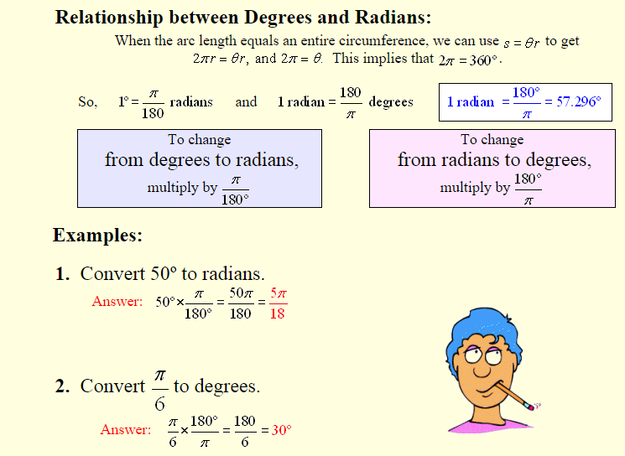

Review: http://www.regentsprep.org/regents/math/algtrig/atm1/arclengthlesson.htm
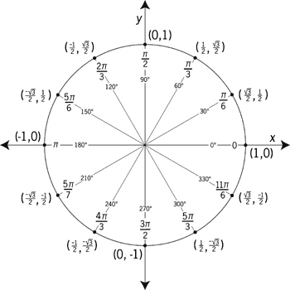

Understand the following Tasks
- Find the radius, area, and perimeter of the circle.
- Convert radians to degrees.
- Convert degrees to radians.
- Find the area of a polygon (hexagon).
- Find the area of a shaded region.
- Find the arc length in cm & radians.
- Describe the difference and similarity between degrees and radians.

